AR Executive Dashboard — Project Description
AR Executive Dashboard provides management with a consolidated view of the organization's Accounts Receivable position, overdue exposure, collection performance, DSO, and payment performance as of the defined data cutoff date.
Business Purpose
Tools: Power BI, DAX, Power Query
Domain: Accounts Receivable (AR) / Order-to-Cash (O2C)
Data Cutoff: 31 July 2026
The dashboard follows a management-to-detail analytical flow:
Executive Overview → Customer Exposure → Invoice Investigation
Beginning with the overall AR position, moving to customer-level exposure, and finally allowing invoice-level investigation through drill-through. This structure enables management to identify areas of receivables exposure and investigate the underlying invoices without overcrowding the executive view.
Data & Calculation Scope
The dashboard uses customer, invoice, payment and calendar data to derive AR exposure, overdue amounts, collection performance, payment performance and DSO. Invoice-level calculations are used to support customer aggregation and invoice-level investigation. It uses data cut off date of 31 July 2026 for consistent calculations.

The dashboard presents key AR KPIs including:
- Outstanding AR
- Overdue AR
- Overdue %
- Collection Rate
- DSO (Days Sales Outstanding)
- On-Time Payment %
It provides an executive-level snapshot of the overall receivables position and helps management quickly assess the scale of outstanding receivables, overdue exposure, collection efficiency, and customer payment performance.

Dashboard Structure
Page 1 — AR Executive Overview
- Overall AR exposure
- Overdue receivables
- Collection performance
- DSO
- On-time payment performance
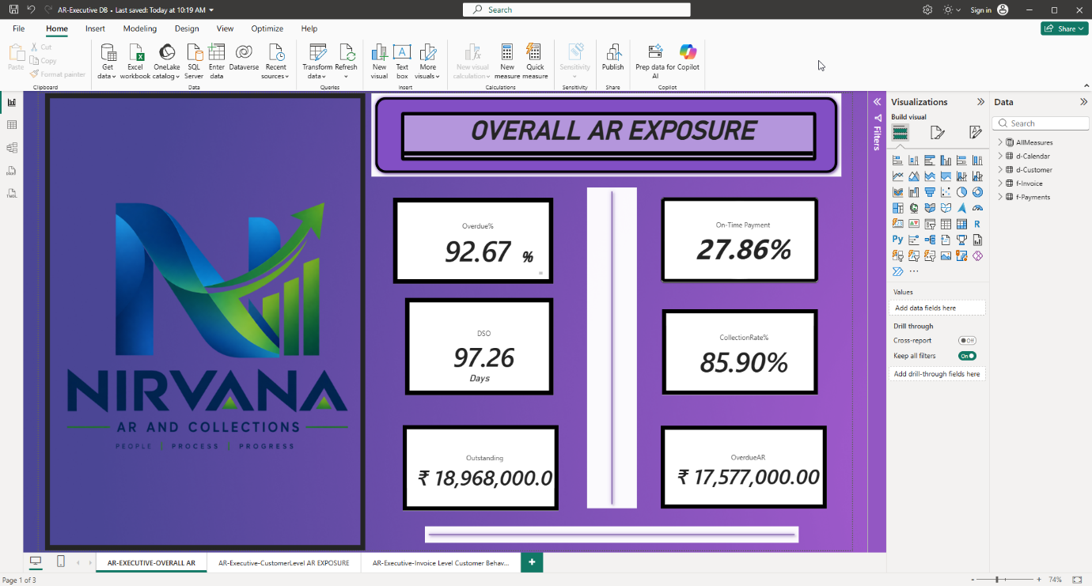
Page 2 — Customer Level AR Exposure
- Customer-wise Outstanding AR
- Invoice Count
- Overdue AR
- Overdue %
- Customer-level exposure analysis
Drill-Through Functionality
The Customer Level AR Exposure page provides customer-level analysis. Users can drill through from a selected customer to the Invoice Level Customer Behaviour page to investigate the underlying invoices, payment status, outstanding amount, days overdue, payment delay and ageing bucket.
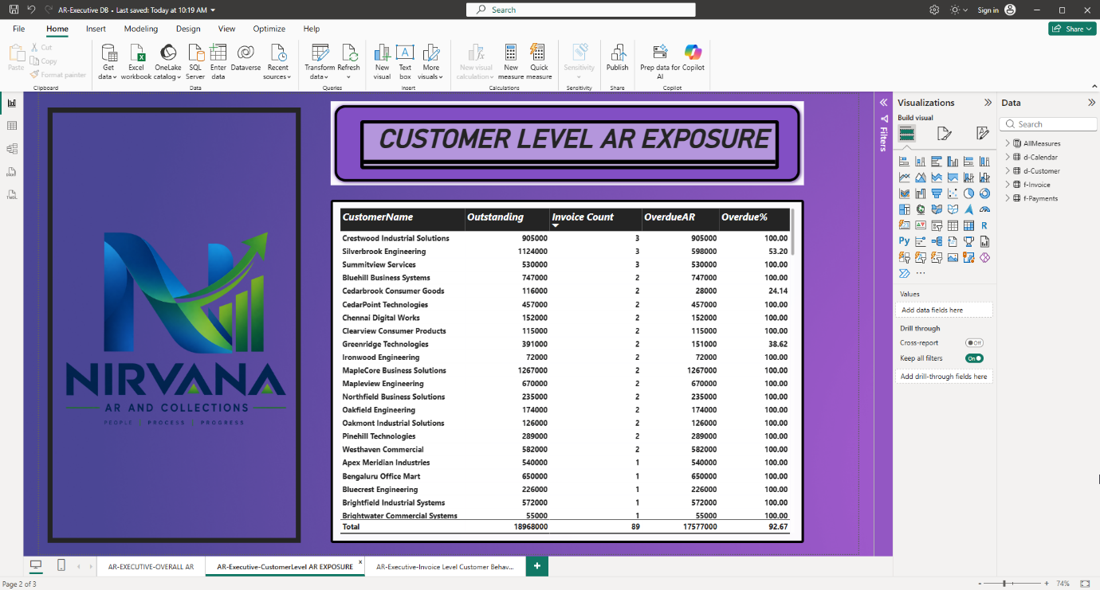

Page 3 — Invoice Level Customer Behaviour
- Drill-through from customer level
- Invoice ID and dates
- Invoice amount and payments
- Outstanding amount
- Days overdue
- Payment status
- Payment delay
- Ageing bucket


